Angling Council Ireland Safeguarding Policy and Procedures for Children & Vulnerable Persons
  - Safeguarding 1, 2 and 3 requirements for ACI and member federations
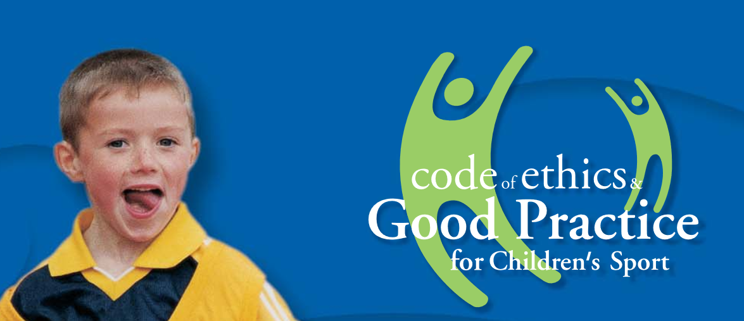

As part of our safeguarding policy the Angling Council Ireland will:

• promote and prioritise the safety and wellbeing of children and young people

• ensure everyone understands their roles and responsibilities in respect of safeguarding and is provided with appropriate learning to recognise, identify and respond to signs of abuse, neglect and other safeguarding concerns relating to children and young people

• ensure appropriate action is taken in the event of incidents/concerns of abuse and support provided to the individual/s who raise or disclose the concern

• ensure that confidential, detailed and accurate records of all safeguarding concerns are maintained and securely stored

• prevent the employment/deployment of unsuitable individuals and maintain a safe recruitment and vetting policy

• ensure robust safeguarding arrangements and procedures are in operation.

Safeguarding Statement for Children and Young People in Angling
Angling Council Ireland acknowledges the duty of care to safeguard and promote the welfare of children and vulnerable adults and is committed to ensuring safeguarding practice reflects statutory responsibilities, government guidance and complies with best practice and Sport Ireland requirements. The policy recognises that the welfare and interests of children are paramount in all circumstances. It aims to ensure that regardless of age, ability or disability, race, religion or belief, sex or sexual orientation, socio-economic background, all children have a positive and enjoyable experience of sport in a safe and child centred environment and are protected from abuse whilst participating in angling or outside of the activity. Angling Council Ireland acknowledges that some children, including disabled children and young people or those from ethnic minority communities, can be particularly vulnerable to abuse and we accept the responsibility to take reasonable and appropriate steps to ensure their welfare by working with the child's parents or carers.
As part of our safeguarding policy Angling Council Ireland will:
- promote and prioritise the safety and wellbeing of children and young people
- ensure everyone understands their roles and responsibilities in respect of safeguarding and is provided with appropriate learning to recognise, identify and respond to signs of abuse, neglect and other safeguarding concerns relating to children and young people
- ensure appropriate action is taken in the event of incidents/concerns of abuse and support provided to the individual/s who raise or disclose the concern
- ensure that confidential, detailed and accurate records of all safeguarding concerns are maintained and securely stored
- prevent the employment/deployment of unsuitable individuals and maintain a safe recruitment and vetting policy
- ensure robust safeguarding arrangements and procedures are in operation.
Our Code of Ethics and safeguarding policies and guidelines are listed below for download and are mandatory for everyone involved with children in Angling Council Ireland and our affiliate federations. Angling Council Ireland is committed to ensuring children and young people enjoy their sport in a safe, fun and fair way and we would appeal to everyone involved in sport to play their part. Child protection in sport is all our responsibility. We all have a duty to care to act if we have a concern for a child or a young person. The wellbeing and safety of all children and young people is paramount and all Angling Council Ireland coaches are vetted and undergo safeguarding awareness training as required by legislation. Each of our juvenile clubs / Hubs have appointed a Club Children's Officer and a Designated Liaison Person to deal with any concerns that may arise. Angling Council Ireland has appointed a National Children’s Officer, who supports all clubs and members throughout the country. If you have any concerns about a child in your community please contact your local Tusla office (Child and family Agency) or Garda station. If you have any concerns about a child or vulnerable adult in your club or ACI member organisation you can contact Bob Seward on 085 8436459 or by email at bobseward08@gmail.com

The following downloads are our policies, procedures and guidelines for working with children vulnerable adults and young people in angling.
- Code of Ethics for Children in Sport
- ACI Garda Vetting Policy & E-vetting Procedures
- ACI A Child Friendly Club
- ACI Child Safeguarding Policy
- National Children’s Officer – Liaison Person contact details
- ACI Data Protection Protocols
- Child Welfare Guidelines
- ACI Safety Policy /Statement /Risk Assessments
- ACI Safeguarding Statement
- ACI Safeguarding Risk Assessments
- ACI Complaints & Disciplinary Procedures

Child Safeguarding Training Policy for Angling Council Ireland

Rev 09/2017

This policy is part of the Safeguarding Statement for the Angling Council Ireland under the Children First Act 2015 Section 11(3).
.
This policy sets out the accepted Safeguarding Workshops for Angling Council Ireland together with any specific requirements for attendance and renewal of certification.

A list of typical roles required by Angling Council Ireland to attend training appropriate to their role is included at the end of this policy
.
Any individual whose role will have regular contact with children or vulnerable
persons in the provision of relevant services must complete safeguarding training.

If you do not hold a valid safeguarding training certificate, you cannot continue
in your role until you refresh your safeguarding training
.
You must also have successfully completed the vetting process with Angling Council Ireland before you can work with children and vulnerable persons. E-vetting must be refreshed at a minimum every four years or as directed by ACI executive.
.
Sport Ireland Safeguarding workshops are outlined as follows; these courses are delivered through your Local Sports Partnership and may be arranged through Angling Council Ireland on request.
.
Safeguarding Training Requirements for All Sports Leaders and Coaches.

1. Safeguarding 1-
Basic Awareness in Child Protection (Face to face workshop)
Validation period: 4 years

Expected attendees: any person working with or has interaction with or who is involved in the planning/administration of our activities or events with our young members. Renewal: Safeguarding 1 certificate may be renewed by completing; Safeguarding 1 (face to face workshop) Or Safeguarding 1 Refresher (e-learning module– see below)

Safeguarding 1 Refresher
-
Basic Awareness in Child Protection - online E-learning module Prerequisite: Valid
Safeguarding 1 certificate Validation period: 4 years.
Expected attendees: any person having completed Safeguarding 1 (face to face workshop) within the last 4 years

Renewal:
Safeguarding 1 Refresher certificate may only be renewed by attendance at Safeguarding 1 (face to face workshop)
Web link for Sport Ireland Safeguarding 1 E-Learning Refresher course:
:
Click here to access:
https://able.ineqe.com/apps/sportireland/coaches/

2) Club Children’s Officer training requirements.
Club Children’s Officer Workshop-
Safeguarding 2

Prerequisite: Valid Safeguarding 1 certificate Validation period:
4 years recommended Expected attendees: any person taking on the role of Club Children’s Officer (but others can attend)

Renewal:
Safeguarding 2 certificate may only be renewed by attendance at Safeguarding 2 (CCO face to face workshop)

3) Designated Liaison Person training requirements.
1. Designated Liaison Person Workshop
Safeguarding 3 Prerequisite:
Valid Safeguarding 1 or Safeguarding 2 certificate Validation period: 4 years
Expected attendees: any person taking on the role of Designated Liaison Person
(Others may attend)

Renewal: Safeguarding 3 may only be renewed by attendance at Safeguarding 3 (Face to face workshop)

Renewing Safeguarding certificates: Safeguarding training requires renewal every 4 years
.
Renewal may be achieved by attending any of the above Safeguarding workshops
where the prerequisites required are met.

Roles requiring Safeguarding 2 must be renewed by attending a Safeguarding 2
(Face to face workshop)
.

Roles requiring Safeguarding 3 must be renewed by attending a Safeguarding 3
(Face to face workshop)
.

Roles requiring safeguarding training Safeguarding 1 Safeguarding 2 and Safeguarding 3

Safeguarding 1 (Who needs to attend)

Sports Leader/Coach
Committee Member
Supervisor
Staff
Team Manager
Chairperson
Mandated Person
Designated Liaison Person
Club Children’s Officer
Tutor/Mentor
Parent/Helper

Safeguarding 2 (Who needs to attend) Club Children’s Officer

Safeguarding 3 ( Who needs to attend) Club Designated Liaison Person

Footnote:
• Validation period commences from the date of workshop completion
/date of certificate

• Angling Council Ireland will allow a grace period after the certificate expiry date of 3 months
in which the individual must complete the required workshop.

Top of Form
Bottom of Form

Notes

Top of Form
Bottom of Form

